Worksheet for “The country of Warrior King”

- Vocabulary
- _____Plantain a. very
- _____fufu b. fried bananas
- _____kente c. produces great result
- _____intensified d. Ghanaian cloth
- _____fertility e. famous spicy food

- Facts
-which one is Ghana’s flag?
A. 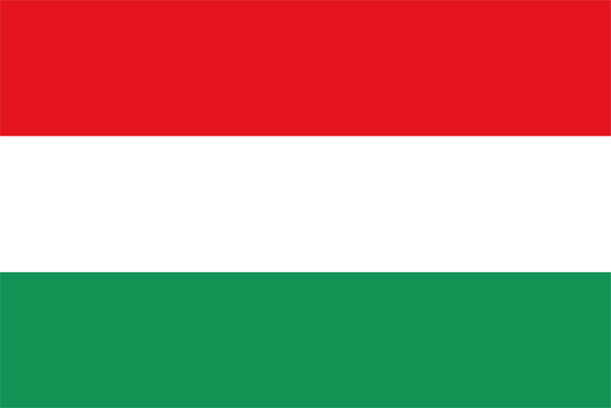 B. 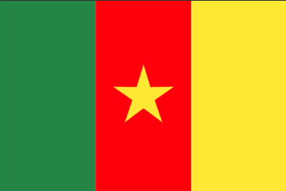
C. 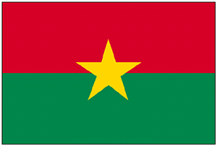 D. 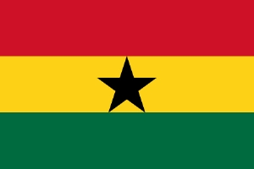

Answer: ______________

- Food
What is this? Circle the right one.
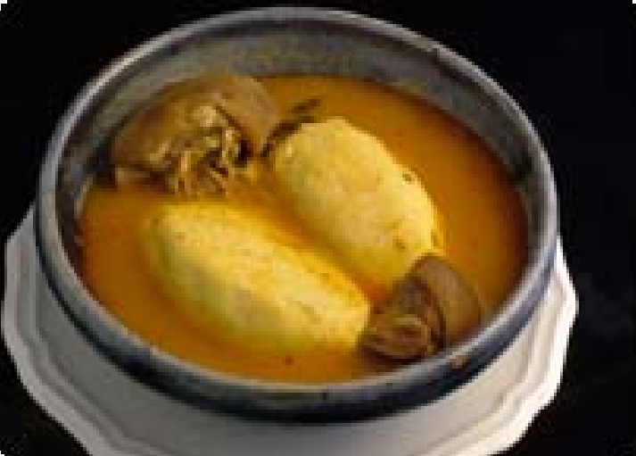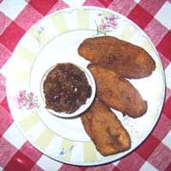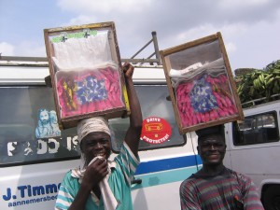
- Tofu b. kanfu a. banana b. fried potato a. ice cake b. fan ice
C Fufu d. rice cake c. plantain d. protein c. foot ice d. shaved ice
4. Sports
Fill in the blanks
In Ghana, is the most popular sport. There are some men’s football teams. “The Black Stars”, “The Satellites” and “The Black Starlets”. To play for “ ” is every schoolboy’s dream.

5. Fashion
Connect the meanings of the colors.
Black ・Vegetation, planting, harvesting, growth
Blue ・Political, spiritual mood, bloodshed, sacrificial
Green ・Maturation, intensified spiritual energy
Red ・Peacefulness, harmony and love
Yellow ・preciousness, royalty, wealth, fertility

