Answer
A. Vocabulary
*Match the words with their meanings*

1. Population a. the opposite the reverse side of the earth
2. Heritage b.four corners
3. Square c.registered place or buildings
4. Antipode d.the number of people
5. Spice e.hot, they are in curry

1.d 2.c 3b 4.a 5.e

- Listening for detail

*Full in the blank spaces*

Do you know the Easter ( Island )? Have you ever ( eaten ) pastel de chocuko? Can you ( guess ) what country all these are connected to?

Chile is a (public ) in the South America continental southwest shore. The ( capital ) is Santiago and formal name is Pep de Chile. Population of 15,116,435 and total area is 756,102( square ) kilometers. It is about twice Japan. Also Chile has many famous ( world heritages ).In addition, There is no rain in Chile.

- Which is the flag of Chile?

*Choose the answer*

A. B. C.

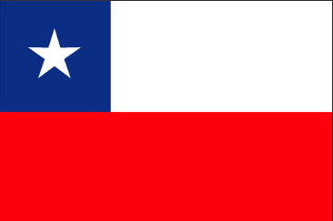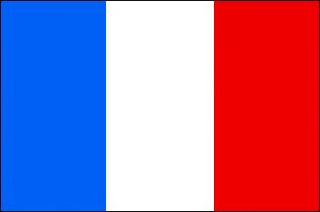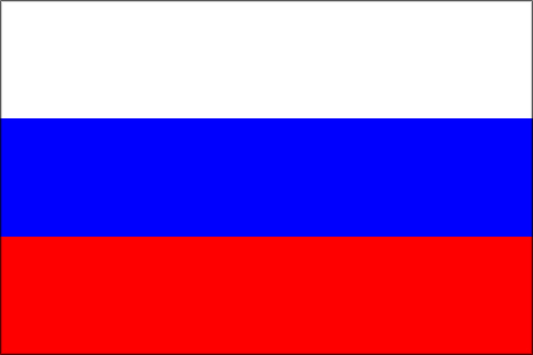

Answer. A

D.True or False
*Listen and answer True (T) or False (F)*
1. T/F This country’s antipodes is Japan A.F
2. T/F Now, there about 1,000 of Moai stone statue in Easter Island A.T
3. T/F Mother language is English A.F
4. T/F There is no rain A.T

