Work sheet

A. Vocabulary

Match the words with their meanings

1. Industry
2. Agroforestry
3. Civilization
4. Especially
5. Cultivate

a. businesses that produce a particular type of thing or provide
a particular service
b. agriculture, forestry, stock farming, the marine products industry
c. a society that is well organized and developed
d. to use land for growing crops and plants
e. used to emphasize that something is more important

B. Listening for detail
Fill in the blank spaces
Have you heard of ? Do you know about ? Have you ever eaten ? Can you guess what country all these are connected to?

Hi. Our names are Emi.S and Emi.K. Welcome to this country spotlight. I'd like to introduce Honduras to you on this show. Honduras is a very beautiful country with lots of history that located in the part of . I'll be talking about a few basic , some history and Honduran cuisine. Let's start.
Basic facts
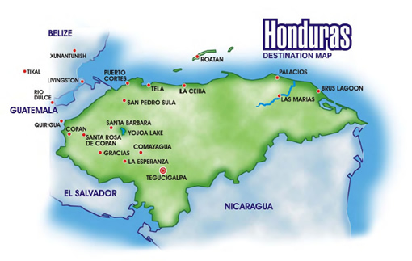
This country’s formal name is of Honduras. Everyone usually call Honduras. This country is located in the part of America. The capital is Tegucigalpa, public language is Spanish. The area is 112.090 kilometers and where 7,466,000 people lives. Currency is Lempira(LNL), 1 doll is 18.9 Lempira. Main religion is . Main industry is which are coffee, banana, farmed shrimp.

C. True or False

- T / F Honduras is located in the part of South America.
- T / F Honduras was discovered by Columbus in the 1600s.
- T / F Public language is Portuguese.
- T / F Honduras’s currency unit is Lempira.
- T / F Coffee and Banana are famous as local products.

